**English 1**

0101, 3 Credit Hours

Saturday 08:00-10:00 – Room 17

Spring Semester 2020

**Instructor: Muhammad K. Radwan**

Email: [gh93st@gmail.com](mailto:gh93st@gmail.com)

**Grading Procedures:**

|  |  |
| --- | --- |
| Assignment | Marks |
| Attendance | 10 |
| Assignments | 5 |
| Quizzes | 10 |
| Midterm Exam | 25 |
| Final Exam | 50 |

**GPA:**

|  |  |
| --- | --- |
| Grade | Points |
| A | 4 |
| B+ | 3.5 |
| B | 3 |
| C+ | 2.5 |
| C | 2 |
| D+ | 1.5 |
| D | 1 |
| F | - |

**GPA = Credit Hours * Point**

**Index**

|  |  |  |  |
| --- | --- | --- | --- |
| **Lesson** | **Vocabulary & Reading** | **Grammar** | **Page** |
| Lesson 1 | DNA | Relative Clauses | 1 |
| Lesson 2 | Plant Adaptations |  | 6 |
| Lesson 3 | Animal Adaptation | Comparisons |  |
| Lesson 4 | Living and None-Living Things | Articles a, an, the |  |
| Lesson 5 | Trees |  |  |
| Lesson 6 | Animal Classifications |  |  |
| Lesson 7 | The Cell |  |  |
| Lesson 8 | Photosynthesis | The passive |  |
| Lesson 9 | Amphibians |  |  |
| Lesson 10 | Food Labels |  |  |
| Lesson 11 | Scientific Names |  |  |
| Lesson 12 | Blood and the Body |  |  |

**Course Schedule**

|  |  |
| --- | --- |
| Date |  |
| 1/3 – Sat. |  |
| 8/3 – Sat. |  |
| 15/3 – Sat. |  |
| 22/3 – Sat. |  |
| 29/3 – Sat. |  |
| 5/4 – Sat. |  |
| 12/4 – Sat. | Midterm |
| 19/4 – Sat. |  |
| 26/4 – Sat. |  |
| 3/5 – Sat. |  |
| 10/5 – Sat. |  |
| 17/5 – Sat. |  |

**English for Biology Students**

**Muhammad K. Radwan**

**Lesson1: DNA**

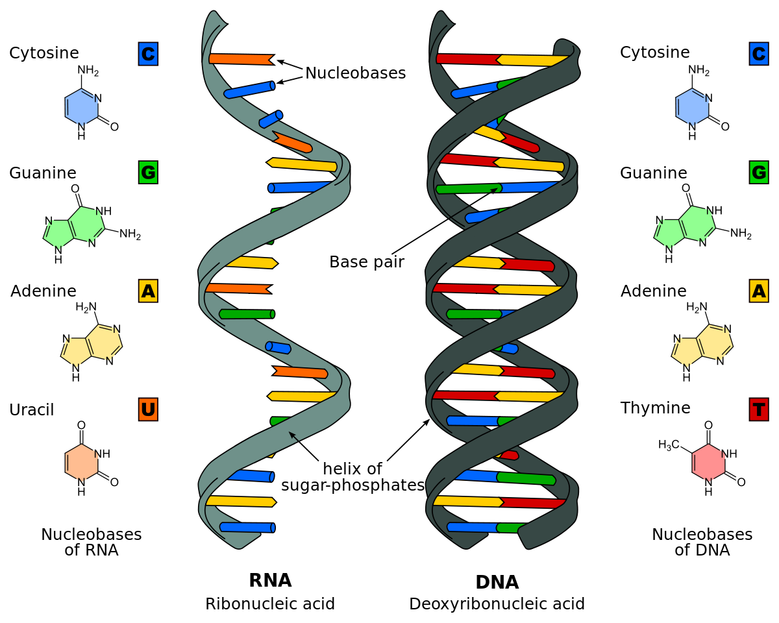

**A- Vocabulary**

**A1- Match the words to the definitions.**

|  |  |  |  |  |
| --- | --- | --- | --- | --- |
|  | Deoxyribonucleic acid (DNA). |  |  | The structure of a DNA molecule. |
|  | Nucleotide. |  |  | The process of recording and/or examining a person's pattern of genes, often to prove that they did or did not commit a crime. |
|  | Double Helix |  |  | A part of the DNA in a cell that controls the physical development, behavior, etc. of an individual plant or animal and is passed on from its parents. |
|  | Gene |  |  | The chemical, present at the center of the cells of living things, that controls the structure and purpose of each cell and carries genetic information during reproduction. |

**B- Reading.**

We all know that humans only give birth to humans; elephants only give birth to little elephants, giraffes to giraffes, dogs to dogs and so on for every type of living creature. But why is this so? The answer lies in a molecule called **deoxyribonucleic acid (DNA)**, which contains the biological instructions that make each species unique. DNA, along with the instructions it contains, is passed from adult organisms to their offspring during reproduction.

DNA, or **deoxyribonucleic acid**, is the hereditary material in humans and almost all other organisms. Nearly every cell in a person's body has the same DNA. Most DNA is located in the cell nucleus (where it is called nuclear DNA), but a small amount of DNA can also be found in the mitochondria (where it is called mitochondrial DNA).

The information in DNA is stored as a code made up of four chemical bases: **adenine** (A), **guanine** (G), **cytosine** (C), and **thymine** (T). Human DNA consists of about 3 billion bases, and more than 99 percent of those bases are the same in all people.

The order, or sequence, of these bases determines the information available for building and maintaining an organism, similar to the way in which letters of the alphabet appear in a certain order to form words and sentences. DNA bases pair up with each other, A with T and C with G, to form units called base pairs.

Each base is also attached to a sugar molecule and a phosphate molecule. Together, a base, sugar, and phosphate are called a **nucleotide**.

Nucleotides are arranged in two long strands that form a spiral called a **double helix**. The structure of the double helix is somewhat like a ladder, with the base pairs forming the ladder's rungs and the sugar and phosphate molecules forming the vertical sidepieces of the ladder.

An important property of DNA is that it can replicate, or make copies of itself. Each strand of DNA in the double helix can serve as a pattern for duplicating the sequence of bases. This is critical when cells divide because each new cell needs to have an exact copy of the DNA present in the old cell.

DNA contains the instructions needed for an organism to develop, survive and reproduce. To carry out these functions, DNA sequences must be converted into messages that can be used to produce proteins, which are the complex molecules that do most of the work in our bodies. Each DNA sequence that contains instructions to make a protein is known as a **gene**.

The size of a gene may vary greatly, ranging from about 1,000 bases to 1 million bases in humans. Genes only make up about 1 percent of the DNA sequence. DNA sequences outside this 1 percent are involved in regulating when, how and how much of a protein is made.

Forensic scientists can use DNA in blood, semen, skin, saliva or hair to identify a matching DNA of an individual. This process is formally termed **DNA profiling**, but may also be called **genetic fingerprinting**. In DNA profiling, the lengths of variable sections of repetitive DNA, such as short tandem repeats and minisatallites, are compared between people. This method is usually an extremely reliable technique for identifying a matching DNA.

**B1- Answer the following questions:**

1. **Which of the following is the hereditary material found in humans and almost all other organisms?**

A: Deoxyribonucleic acid

B: Muriatic acid

C: Nuclear acid

D: Bicarbonate acid

1. **Which of the following is NOT one of the information chemicals stored in DNA?**

A: adenine

B: guanine

C: cytosine

D: sulfide

1. **In DNA, the two long strands that form a spiral are called which of the following?**

A: Double strand

B: Ladder

C: Double helix

D: Spiral helix

1. **DNA contains the instructions needed for an organism to do all but which of the following?**

A: Survive

B: Develop

C: Reproduce

D: Breath

1. **Each DNA sequence that contains instructions to make a protein is known as which of the following?**

A: A gene

B: A hormone

C: A nucleus

D: A sequence

1. **Forensic scientists can use DNA in blood, skin, saliva or hair to identify a matching DNA of an individual. This process is formally called which of the following?**

A: DNA pictures

B: DNA profiling

C: DNA publication

D: DNA projections

**C- Grammar: Relative Clauses**

* A clause is a is a group of words with a subject and a verb. A relative clause is only a part of a sentence. It adds meaning to the main clause of a sentence.
* ***Who***, ***which*** and ***that*** introduce relative clauses, they refer back to a noun, and stand instead of a noun. The introduce a new idea about the noun. Examples:
  + DNA sequences must be converted into messages. Messages can be used to produce proteins.
  + DNA sequences must be converted into messages ***that can be used to produce proteins.***
* Use ***who*** or ***that*** for people
  + A Zoologist is a person **who/that** studies animals.
* Use **which** or **that** for things and animals.
  + Messages that can be used to produce proteins, **which** are the complex molecules that do most of the work in our bodies

**C1- Write *who, which* or *that***

* 1. Arthur pan lives in a house _______ his family built.
  2. A botanist is a person _______ studies plants.
  3. We climbed over the fence _______ separates the fields.
  4. I spoke with the boy _______ was walking in the street.
  5. Those are the subjects _______ I study in college.

**C2- Join the following sentences**

1. Bill was the man. He invented the telephone

___________________________________________________

1. Gold is a heavy metal. It's valuable.

___________________________________________________

1. A bus broke down. It takes people to the airport.

___________________________________________________

1. A woman wanted to speak to you. She phoned last night.

___________________________________________________

e. A policeman has received an award. He rescued 15 people from a fire.

**D- Sources**

1. (2020, March 13). Retrieved from Cambridge Dictionary: https://dictionary.cambridge.org/dictionary/
2. *DNA Reading Comprehension*. (2020, March 08). Retrieved from Softschools: <https://www.softschools.com/language_arts/reading_comprehension/science/147/dna/>
3. Macfarlane, M. (1998). *English Practice Grammar.* Berkshire: Garnet Publishing Ltd.

**Lesson2: Plant Adaptations**

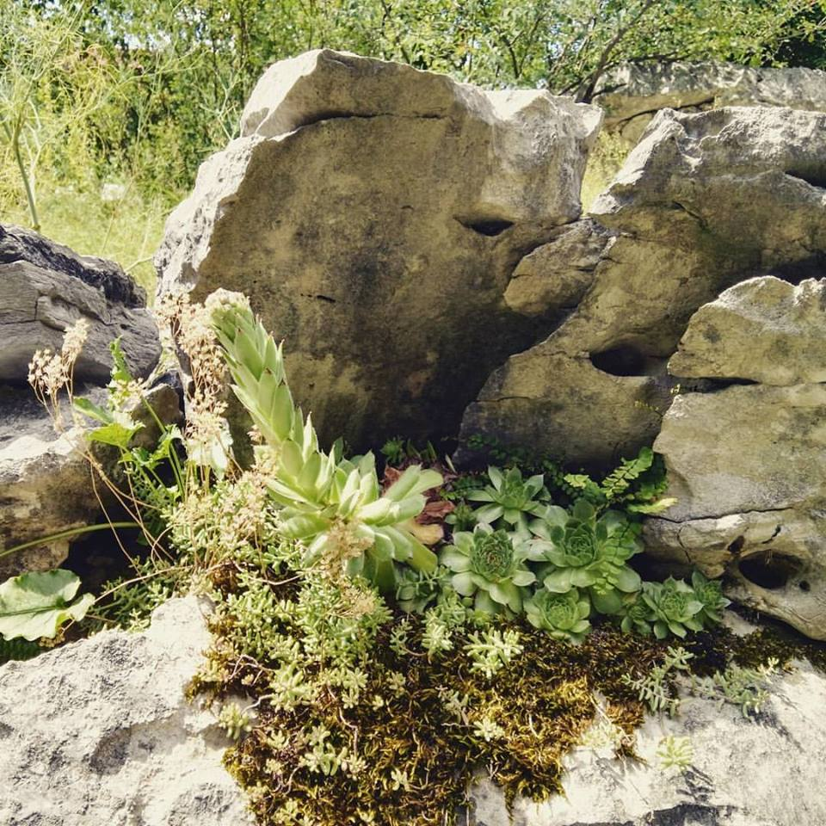

**A- Vocabulary**

**A1- Match the words to the definitions.**

|  |  |  |  |  |
| --- | --- | --- | --- | --- |
|  |  |  |  |  |
|  |  |  |  |  |
|  |  |  |  |  |
|  |  |  |  |  |

**B- Reading**

Plants have **adaptations** to help them live and grow in different areas. They can even grow in water. They develop many different adaptations for their survival.

One example is plants growing in the desert areas of the world. **Desert plants** take in a lot of water quickly when it rains. Since it does not rain very often, the plants have to store the water in their **stems**, which have a thick, waxy coating which helps seal in the water.

The **spines** on some desert plants also help with their survival by keeping away animals who want to eat them. The spines also act like **leaves** holding in the water during the hot weather. **Cactus plants** need to store a lot of water. Some desert plants have leaves with hair to shade them from the sun. These hairs help stop water loss, too. Other plants in the desert turn away from the sun during the day and receive less heat. Some desert plants overcome the problem of the lack of water by growing long **roots** that go deep into the ground for water.

The plants who choose to fight to live have special stems and roots to absorb and store water deep under the ground.

Hot sun and heavy rains make the best areas for plants and animals to grow. Over half of all plant types live in the **tropical rainforests**. Tropical rainforests are the places where plants grow the best. The trees grow very close together. They need the sun to make food. In a thick forest where there are a lot of trees, plants cannot reach the sun easily. They may not live. In order to reach the sun, plants have to grow or climb on others. Only 2 percent of sunlight reaches the forest floor. The ground is very damp. Water carries food from the **soil** up to the plant so that the plant may live. If the ground is dry, the plant won't get enough water to carry the food. Plants absorb their **nutrients** from the soil. The nutrients are taken up through the stems of many plants to feed the plant.

Because rainforests get large amounts of rain, too much water can also be damaging to plants. An adaptation called a **drip-tip** on leaves allows the water run-off to save the plant from getting too much moisture.

In **grasslands**, also called prairies, plants must adapt to the dry climate where the summers are hot and the winters are cold. Because it is very dry, the roots go way below the ground to reach the water. If they need protection from animals, the plants may have thorns or spikes.

Strong steady winds blow over the grasslands and remove the water from the ground or air so trees usually cannot grow there. Though, **savannas**, many located in Africa, are places in grasslands that do have some trees.

In a **tundra**, it is very dry and cold. The blanket of snow covering the tundra in winter helps plants keep warm and protects them from damaging winds. Roots of tundra plants grow just under the surface of the ground where they can be close to the melting snow. It also keeps plants from freezing. Collecting this water is very important for these plants because the high winds can dry them out easily.

Finally, thousands of plant types grow in water all over the world. Ocean **seagrass** has stems that enable them to cope with the tugging of currents and waves. Roots grow down to anchor the plant to the **seabed**, while other blades grow straight up and bend easily. Ocean plants also have to be able to handle the dissolved salt in the water. They have the ability to break down the salt into different parts. This can cause beds of oceanic plants to control the amount of salt in the water surrounding them.

Plants are found all over the world because they have developed adaptations to survive the different climates.

**B1- Answer the following questions**

1. **Which of the following help desert plants with their survival by keeping away animals and acting like leaves to hold in water?**

A: Stems

B: Spines

C: Roots

D: Drip-tips

1. **Where do half of all the plants live in the world?**

A: Tropical rainforest

B: Tundra

C: Deserts

D: Prairies

1. **Which of the following can be found on grasslands?**

A: Cactus

B: Water lilies

C: Savannas

D: Seagrass

1. **Which of the following is also the same as a prairie?**

A: Grassland

B: Desert

C: Tundra

D: Rainforest

1. **How does a blanket of snow help plants living in the tundra?**

A: Keeps them warm

B: Protects them from damaging winds

C: Melting snow reaches the shallow roots

D: All of the above

1. **Which of the following type of plant has roots that anchor it to the seabed?**

A: Water lilies

B: Ocean seagrass

C: Cactus

D: All of the above

**C- Grammar: Relative Clauses**